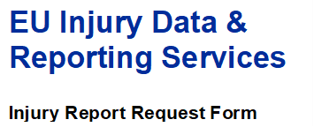

IDB-FDS data contain most valuable information on external circumstances of injuries, e.g. location of injury, activity carried out when injuries, involved products or substances. With this form you can request an offer for a summary report on a specific issue.

A standard report contains the number of specific cases, registered in emergency departments of hospitals according to the IDB-standards, during the years 2010-2016, as well as breakdowns by country, reporting year, age, sex, location, activity, involved products or substances and other interesting IDB-FDS data elements. If possible, you will also get an estimated number of cases, which occur annually in the entire EU-28.

Please note: This service is subject to a cost-covering fee of EUR 600 plus 21% VAT per working day. For a simple, straight-forward report we will charge a lump sum of EUR 400 plus 21% VAT.

Please DESCRIBE YOUR REQUEST: E.g. injuries of toddlers involving baby walkers, sports injuries of adolescents (15-29), traumatic brain injuries of bicyclists, injuries among elderly (+65) in bathrooms, cases of carbon monoxide poisoning…

…

Please INDICATE the PURPOSE OF the request AND THE INTENDED USE of the results: E.g. risk assessment of child safety products, press release for a sports safety campaign, report on vulnerable road users, lecture at a geriatrics conference…

…

Please provide your contact details: Name, Organisation, e-mail, phone-nr.

…
…
…

Please send this form AS Attachment to Your Mail to:
rupertkisser@yahoo.de or s.turner@swansea.ac.uk

