Country update on Injury Surveillance: Slovenia
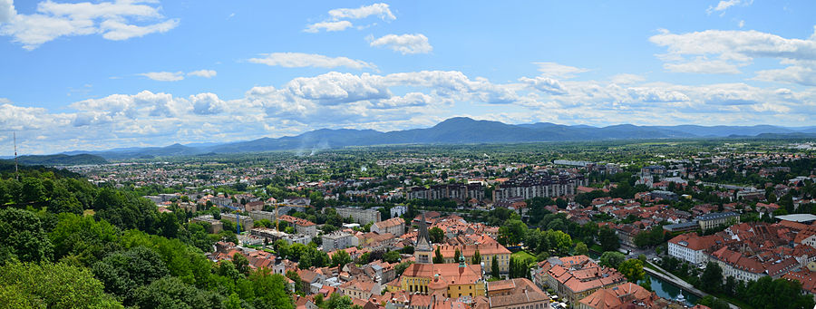
Background
In Slovenia injuries are one of the major public health problems that the government needs to address. When all age groups are taken together, injuries rank the third after cardio-vascular diseases and neoplasms and cause 1.400 deaths per year. Injuries are also the second leading cause of healthy life years lost because they disproportionately affect younger people and high burden in young people reflects both a greater number of years of life lost and more years lived with disability for the survivors.

The health sector plays an important role in multi-sectoral approach to injury prevention by developing injury surveillance system, research, setting priorities for action plans and developing interventions.

How it started
National mortality and hospital discharge statistics provide key information about external cause and type of injury which has been used for national policies and setting priorities for injury prevention in Slovenia.
But some information for guiding comprehensive policies and developing specific injury prevention interventions was still lacking, in particular information about activities, involved products, services and environments where accidents occur, the precise injury mechanisms and their consequences.

In order to obtain additional information on risk factors for injuries a new injury database was developed as a part of the National Hospital Information System and was implemented in 1997. Data collection was mandatory for all Slovenian hospitals according to national law on health information system and databases. The Injury dataset covered information on hospital, injured person, nature of injury, external cause, place, activity when injured and the 10th revision of ICD was introduced into health information system.

In 2004 Slovenia joined the EU Injury Database (IDB) project to participate in building a common European injury surveillance system. At that time it was not feasible to extend injury data collection to emergency departments according to IDB methodology due to national legislative restriction, so then decision was taken to supplement existing hospital admission dataset with new data elements and classifications and improve data reporting to European Injury Database. For the first time it was possible to present national data on injuries and poisonings by selected product, mechanism, detailed place of occurrence and detailed activity when injured.

Data from emergency departments
In 2011 Slovenia joined the JAMIE project and the problem with legislative restriction of data collection at emergency departments was solved by using new methodological approach based on national sample of hospitals, which provide enough information for prevention purposes and allow for national estimates of incidence rates.

In Slovenia emergency department data on injuries and poisonings are part of the Out-Patient Specialist Services Database, where reports are submitted for each patient treated in the out-patient specialist services. Due to the fact that the Out-Patient Specialist Services Database is normally submitted to National Institute of Public Health (NIPH) in aggregated form without personal identifier, it was necessary to introduce a separate data capture of individual level records for the purpose of FDS and MDS data preparation, based upon special agreements with four selected sample hospitals, which are representative for the entire country, from 2011 onwards. Captured data for years 2011 to 2014 were then transformed into standard FDS data format according to the Injury Database (IDB) Coding Manual, version 1.1, June 2005 and MDS data format according to JAMIE Manual, August 2012 and by applying bridge coding from ICD-10 according to these coding manuals. In 2013 Australian modification of ICD-10 (6th ed.) was implemented in Slovenia, so from 2013 onwards bridge coding from ICD-10-AM (6th) to ICD-10 was applied to injury data before they were transformed into standard FDS and MDS data format.

At the moment, major renovation of the Out-Patient Specialist Services Database is taking place, so all the out-patient data, including emergency department data on injuries and poisonings, will be reported to NIPH as individual level records from 2018 onwards, and this will enable easy access to injury data in all Slovenian hospitals and its transformation into standard FDS and MDS data format.

Results
Emergency departments in Slovenian hospitals are not legally obliged to collect injury specific variables like place of occurrence, mechanism of injury, activity when injured and underlying object/ substance producing injury. Nevertheless, the injury specific data collected in the sample hospitals for years 2011 to 2014 proved to be to a large extent complete, which also indicates a good validity of the resulting national estimates. The MDS sample covers about 40% of all national discharges and more than 50% of all ambulatory emergency department treatments and FDS sample covers about 30% and 40% respectively.

Data use
Data on injury patterns related to selected products, mechanisms and detailed places of occurrence are used for developing a multi-sectoral child safety action plan, setting priorities, specific actions and preventive measures.

The National Institute of Public in Slovenia is now able to support proposed preventive measures by presenting data on children drowning in private swimming pools, scalds by hot water source, burns by place of occurrence etc. In general the majority of injuries are occurring at home and in leisure environment and most of them involve one or more products.

Data also allows the Institute to systematically monitor injury patterns related to products and places of occurrence and take them into account when designing products, buildings or when defining standards. Ministry of Economic Development and Technology frequently uses data on injuries due to selected products to support adoption of new standards and regulations in order to ensure a high level of safety of products and services for the citizens of Slovenia.

More information:
Tina.Zupanic@nijz.si

