Country update on Injury Surveillance: Denmark
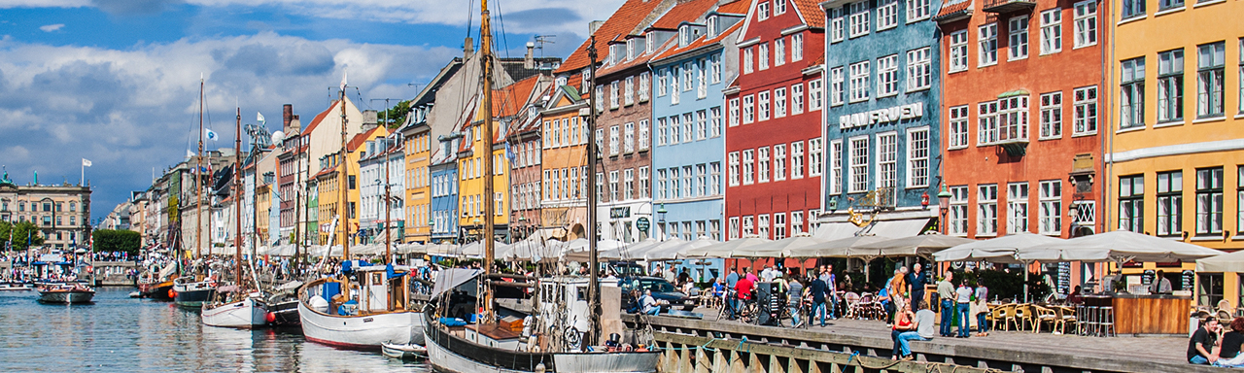

History
Denmark has a long tradition of injury registration in a hospital setting. The first systematic registration was of traffic injuries at Odense Hospital in 1971. This was extended to all accidents in 1976.
In 1988, registration of Home and leisure injuries started at five hospitals as part of the European Home and leisure Accident surveillance system (EHLASS). From 1990 onwards, this registration was extended to all accidents (including road and work related accidents), and from 2008 to all injuries (by including violence and self-harm).

All these registrations are quite detailed, including information on e.g. products involved. While the registration in Odense was part of the routine registration to the national Patient register, the injury register at the five EHLASS -hospitals was run parallel to the mandatory registration to the National Patient Register.

The National Patient Register includes information on all admissions since 1977, and from 1995 onwards, it includes emergency department registrations at all Danish hospitals using a minimum data set containing data on injury mechanism, activity, place, and mode of transport and counterpart for traffic injuries. The information is obtained by interviews made by secretaries when the patient arrives, and coded afterwards. Different classifications have been used for these registrations. Therefore, the data are not always directly compatible. The classifications used are EHLASS and NOMESCO classifications of external cause of injury versions 2, 3, and 4. When introducing the version 4 of the NOMESCO classification in 2008, this classification was implemented at national level allowing for registration of both a minimum dataset and an extended dataset including e.g. products.

In 2010, the Injury register was closed and replaced by a pilot registration at three hospitals, including Odense Hospital. This registration used the extended dataset, while the minimum dataset continued to be used at all other hospitals in Denmark. Due to the lack of funding and budget cuts the pilot study was not continued and ended in 2012.

Current situation
All hospitals in Denmark record data consistent with the IDB-minimum dataset, however without the narrative. An evaluation of the pilot study in 2010-2012 recommended that all hospitals should register a minimum dataset that is much simpler than the previous data set and that should be more in line with the IDB minimum dataset. This was implemented in 2014 and resulted in reduced workload at the hospitals and improved data quality.
Only one hospital is continuing to register injury patients at a detailed level at present: the Odense University Hospital. At this hospital information on sports and products are written as text and coded automatically afterwards. Even this hospital is challenged due to changes in IT systems and the organizational structure, as well as data protection regulation, e.g. narratives cannot be processed without special permission

Use of data
The main purposes of injury registration in Denmark are surveillance and monitoring trends. Both the National Institute of Public Health and the Accident Analysis Group in Odense have published annual reports as well as study reports on injury trends. These have been used by both governmental institutions, NGOs, and the media to put injury prevention on the agenda. One of the successful intervention actions is the action on injuries due to firework – the number of injuries has been reduced significantly during the last decade. Data on traffic injuries have been used to change road crossings to become safer.

By being based on person numbers from 1995 onwards, injury registration can be linked to other register information like socioeconomics, use of medicine, type of dwelling etc. This has been used in several research projects, e.g. on risk factors for childhood injuries and long-term consequences of injury.

The main political interest in injury registration at hospitals has been in the registration of traffic injuries, because these are underreported by the police. Governmental involvement in injury registration and injury prevention for home and leisure injuries has generally been relatively low; this registration has sometimes been dealt with as a “by-product” of the registration of traffic injuries.

The most frequent user of home and leisure injury data is the Danish Safety Technology Authority, which has the responsibility of product safety; they have used the injury data to set priorities.
The National Board of Health is now beginning to set focus on injury prevention and is working on the clarification of the responsibilities between the different ministries. But still, the funding of the collection of a detailed data set from a sample of hospitals remains uncertain for the time being.

More information:
Bjarne Laursen
E-mail: bla@si-folkesundhed.dk

IDB-related publications:
Laursen B, Helweg-Larsen K: Health service use in adults 20-64 years with traumatic brain injury, spinal cord injury or pelvic fracture. A cohort study with 9-year follow-up. BMJ Open 2012 Oct 26;2(5)
Laursen B, Møller H: Long-term health effects of unintentional injuries in Danish adults. Dan Med J 59(5):A4423 (2012)
Hanne Møller, Mathilde Damm, Bjarne Laursen. Ulykker i Danmark 1990-2009. [ Injuries in Denmark 1990-2009] Statens Institut for Folkesundhed, Syddansk Universitet, 2012. [In Danish with English summary]
Toft AM, Møller H, Laursen B: The years after an injury: long-term consequences of injury on self-rated health. J Trauma 69(1):26-30 (2010)

