Country update on Injury Surveillance: Finland
Introduction
Finland first joined EU-level injury monitoring efforts in 1986, through the EHLASS (European Home and Leisure Accident Surveillance System) initiative. From 1992 to 1998 data collection was the responsibility of the Finnish Consumer Authority (since 2013: Finnish Competition & Consumer Authority) and its product-related injuries database. Since 2004 the National Institute for Health and Welfare-THL (until 2009 known as National Institute for Public Health) is acting as the national coordinating agency for injury prevention with an emphasis on home and leisure injuries.

National IDB-system
The Finnish contribution to IDB (as of 2014) in the form of the Minimum Data Set is produced by THL through random sampling of patients’ care episodes from the Care Register for Health Care (inpatients). The register’s size enables uniform and adequate representation of different hospitals, patient groups and accident types. Data in the Care register is coded in ICD-10, hence diagnostic information is re-encoded through conversion tables concerning injury type (12-category variable), accident location (road, school, home, other specified, not known), and accident mechanism. Data is gathered from the start of treatment (by year and month), including any follow-up care.

Insights gained
In Finland, unintentional injuries are the 4th leading cause of death across ages - putting injuries in a par with other major public health concerns. In 2015, 2 161 deaths were caused by injury or 4% of all deaths. Furthermore, unintentional injuries are the leading cause of death in the population between 1 and 45 years of age. Although the absolute total number of deaths by unintentional injuries falls far behind deaths caused by cardio-vascular diseases and cancers (the mainstay causes of death particularly in older age-groups), a different picture emerges when comparing years of life lost. In this approach of examining the data more weight is given to deaths in young ages.

In Finland unintentional injuries are causing the largest number of years of life lost up until the age of 50, whereby cardiovascular diseases and cancers come in the lead. As for in-hospital treatments, injuries form the diagnosis group with largest number of patients annually and, with over 100 000 care visits per year, belongs also to the top-four diagnosis group in terms of care visits. A similar trend can be seen in outpatient visits, although missing data on diagnosis makes the estimate less reliable.

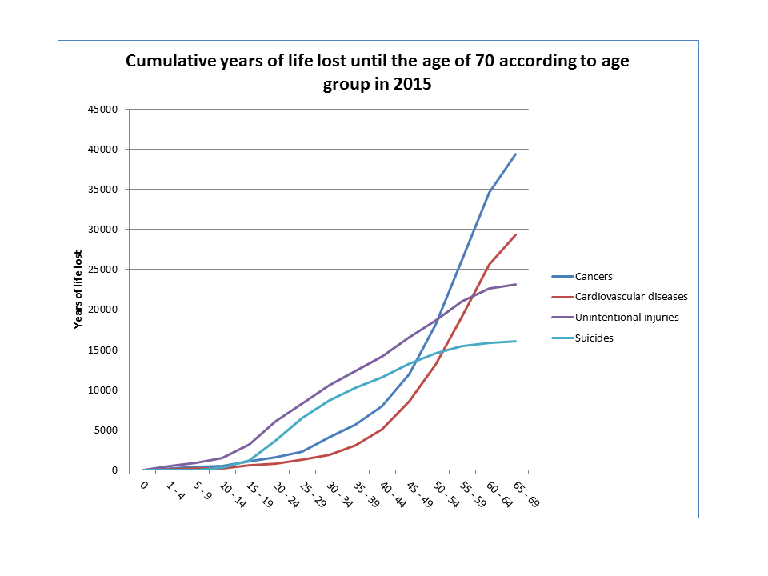
Although injury-related mortality has been steadily declining for over a decade, certain population groups and injury types still require particular attention.
Falls and stumbling caused 1100 deaths in 2015, around one-half of all fatal injuries and predominant in the age group over 65. Just under one-half of stumbling accidents occurred at homes or in the immediate vicinity, and one-quarter in care institutions.
Overall alcohol-related mortality has decreased and so has the presence of intoxication in injury deaths (16% of those involved in fatal accidents in 2015 were intoxicated). Nevertheless, alcohol intoxication played a role in nearly half of sauna-related deaths, drownings and fire deaths and in 20% of fatal transport accidents.
Fatal transport accidents overall have also decreased dramatically (268 deaths in 2015, down by one third since the last decade), however they are the main cause of injury death in the under 25’s.
For the younger and middle-aged adult population, fatal poisonings (average age 40 years for men and 58 for women) and drug related deaths (most absolute numbers among 30-34 year-olds) also pose major issues.

Use of data
In Finland, national injury data and timely and reliable statistics on injuries and their costs are an essential support to national injury prevention programmes and strategies as well as to local injury prevention projects. National level preventive actions are implemented through inter-ministerial collaborations and networks with wide stakeholder representation.

In support of local level activities THL’s injury prevention staff produces since 2008 annual regional injury reports based on FINJURY, the Finnish injury research register. FINJURY includes injury mortality and morbidity data at an individual level from 1971 onwards, augmented with cost data for hospital care. Regional injury reports include figures, tables and indicators by region and municipality on fatal and non-fatal hospital treated injuries, thus supporting local injury monitoring efforts.

Future outlook
Despite the good quality of national data, there is still room for improvement. Coverage on external causes of injuries is good on hospitalisations and visits to secondary care, but in primary care, where many first contacts take place before referral to specialist treatment or e.g. in the case of sports injuries treated by physiotherapists, the registration of external causes is not mandatory.

Further, some types of information such as that arising from accident investigations and various risk data sources should be better linked with the official monitoring systems to improve understanding of the related risks of injuries.
Overall, health data collection in Finland has become fully digital since the operation of the National digital repository for electronic patient documents (Kanta) in 2013. Injury prevention specialists in THL are exploring the possibilities of progressing towards automated injury monitoring. Opportunities for richer and more timely data collection arise e.g. through the Forensic Medicine Information System which aims towards production of fully electronic death certificates, as well as through the forthcoming electronic emergency services record, part of the Multi-Agency Field Commanding System (KEJO) for all Finnish Public Protection and Disaster Relief (PPDR) authorities.
In coupling with enhanced data collection, modern dissemination practices from national data sources can also significantly improve injury prevention efforts. Incorporating injury-specific indicators in the forthcoming updated and more user-friendly reporting system of THL data and indicators is one of our next development steps.

More information:
persephone.doupi@thl.fi

IDB-related publications:
National action plan for injury prevention among children and youth:
http://urn.fi/URN:NBN:fi-fe201205085263

https://www.thl.fi/en/web/injury-prevention/accidental-injuries/statistics;

https://www.thl.fi/documents/568266/1481840/STM_2014_1_tapaturma_eng_appndx2.pdf/597f1137-b862-409d-8b23-93e390b37264

